|  |
| --- |
|  |
| 新概念 3 册 |
| Lesson59 |

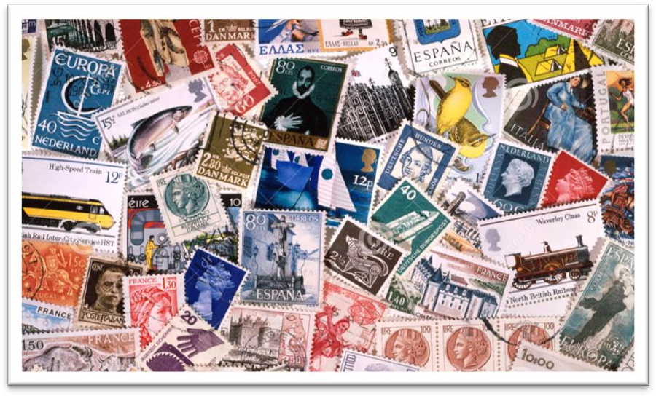Lesson 59 Collecting

**amass [ə'mæs]**

**v. 积累，积聚**

How had he amassed his fortune?

For 25 years, Darwin amassed evidence to support his theories. accumulate

accumulate knowledge / possessions Debts began to accumulate.

However, as the evidence began to accumulate, experts from the Zoo felt obliged to investigate, …

collect / gather

Dust had collected on the window-sill.

I didn't know what to do with it, so it just sat there collecting dust . The darkness is gathering.

You may as well take these books ― they're just gathering dust on the shelf. pile up / build up

Meanwhile, the traffic piled up behind. He piled up huge debts.

Traffic is building up on roads into the city.

The gallery has built up a fine collection of contemporary art.

indiscriminate [ɪndɪs'krɪmɪnət] adj. 不加选择的

be indiscriminate in …

He is indiscriminate in his choice of friends. discriminate

discriminate against … discriminate against women

discriminate against ethnic minorities discrimination

racial discrimination sexual discrimination religious discrimination **requisite ['rekwɪzɪt]**

**n. 必需品**requisite necessity

daily necessities prerequisite **mania ['meɪniə]**

n. 狂热，癖好；躁狂症

mania / craze soccer mania / craze

fitness mania / craze maniac

a sex maniac kleptomania pyromania megalomania dipsomania bibliomania **remote [rɪ'məʊt]**

**adj. 遥远的；（可能性）微小的** in the remote past / future remote control

The chances are remote / slight / slim / small. The chances are high / good.

The following day, however, the doctor consoled him by telling him that his chances of being able to leave hospital in time for New Year celebrations were good.

strong-minded [strɒŋ 'maɪndɪd] adj. 意志坚强的

strong-minded iron-willed

resolute determined

stubborn obstinate

hesitant

verify ['verɪfaɪ]

**v. 证实，核实**verify data / details testify

testify against sb. / in favor of sb. justify

The end justifies the means.

contented [kən'tentɪd] adj. 心满意足的

a contented heart a contented smile

Whenever he returns to this place he is happy and contented. content

be content with … be content to do …

He is content with his present job.

He is content to stay in his present job. collecting

collection tend to do

have a tendency to do be inclined to do

be apt to do

intend to do mean to do

be going to do plan to do have every intention of doing

have no intention of doing

I had no intention of buying one, but I could not conceal the fact that I was impressed by the size of the diamonds.

amass possessions accumulate belongings

… without being conscious of doing so.

They disregard social conventions without being conscious that they are doing anything extraordinary.

… without being conscious of doing so.

… without knowing so.

… without realizing so.

… (being) unaware / unconscious of doing so.

He used to sleep during the day and work at night, quite unaware of the fact that he had become the ghost of Endley.

造句：人们变老时往往睡得更少，有时候自己都没有意识到。

People tend to sleep less when they get older, sometimes without being aware of doing so. Indeed they can have a delightful surprise when they find something useful *which they did not know they owned*.

delightful surprise painful joy

sweet sorrow hating love

mixed feelings / emotions

Those who never have to move house become indiscriminate collectors of what can only be

described as clutter. move house / home

We’re moving house / home next week. move

We’re moving next week. move to ...

We’re moving to Shanghai. move in

They've bought a new house, but it will need a lot of work before they can move in. move out

Her landlord has given her a week to move out. up sticks / pull up stakes

This is the fourth time in five years that we've had to up sticks / pull up stakes. be called …

be regarded as … be classified as … be branded as …

They leave unwanted objects in drawers, cupboards and attics *for years*, in the belief that they may one day need just those very things.

undesirable / unwelcome in the belief that …

= because they believe that …

The Swedes were the first to recognize that public officials like civil servants, police officers, health inspectors or tax-collectors can make mistakes or act over-zealously in the belief *(=because they believe)* that they are serving the public.

Young men who have reason to fear that they will be killed in battle may justifiably feel bitter in the thought *(=because they think)* that they have cheated of the best things that life has to offer. The men of our family waded down through our flooded meadows with boathooks, in the hope of being *(=because they hope to be)* able to grapple a corner of the raft and pull it out of the current towards our bank.

造句：他每天都吃维生素药丸，相信这样对健康有好处。

He takes vitamin pills every day in the belief that they may benefit his health.

造句：他给这个女孩子写了一封又一封信希望能赢得芳心。

He wrote to the girl one letter after another in the hope of winning her heart. He is just the man wanted by the police.

He is the very man wanted by the police.

He is just the very man wanted by the police.

As they grow old, people also accumulate belongings for two other reasons, lack of physical and mental energy, both of which are essential in turning out and throwing away, and sentiment.

“名词 + 介词 + 关系代词” 引导非限定性定语从句

He has two sons, one of whom died in the war.

She hurried home to feed her cats, one of which had just had kittens.

The most valuable find of all was the ship's log book, parts of which it was still possible to read.

sentiment n. [U] (usu. derog. 通常作贬义) tender feelings of pity, nostalgia, etc. which may be exaggerated or wrongly directed (contrasted esp. with reason)

（对怜悯﹑ 怀旧等的）情感，多愁善感，感情用事（尤与理智相对）

There's no room for sentiment in business.

She was sentimentally attached to this house, for even though it was far too big for her needs, she persisted in living there long after her husband's death.

Things *owned for a long time* are full of associations with the past, perhaps with relatives who are dead, and *so they gradually acquire a value beyond their true worth*.

Things kept / possessed for a longtime …

… full of connections with the past , … relative

a close relative

a distant relative

a direct / straight relative a blood relative

one’s own flesh and blood nostalgia

gradually slowly

little by little / bit by bit by degrees

beyond their true worth above / over their true worth more than their true worth greater than their true value in excess of their true value

appreciate depreciate

The value of our house has appreciated by 50%. The value of our house has depreciated by 50%. intentionally on purpose

accidentally by accident

by chance unintentionally fortuitously

in an attempt to … = in order to …

They closed the road in an attempt to reduce traffic in the city.

Among these I would list string and brown paper, kept by thrifty people when a parcel has been opened, *to save buying these two requisites*.

The actors are listed in order of appearance. list one’s faults

list one’s achievements

save = avoid save sth./doing

Setting down clear rules from the start will save arguments later on. A stitch in time saves nine.

save sb. sth./doing sth.

If you lend me some money, it will save me a trip to the bank. If you tell her the news, it will save me calling her.

They could be saved so much misery and expense if they chose to live in the city where they rightly belong.

I know someone who always cuts sketches out from newspapers of model clothes *that she would like to buy if she had the money*.

know of / about … hear of / about … learn of / about …

Verrazano, an Italian about whom little is known, sailed into New York Harbour in 1524 and named it Angouleme.

… if she could afford them.

… if she could afford such purchases.

As she is not rich, the chances that she will ever be able to afford such purchases are remote; but she is never sufficiently strong-minded *to be able to stop the practice*.

chances that … / of … are remote / slight / slim / small chances that … / of … are high / good

there is little chance of …

There is little chance of her being able to afford such purchases. strong-minded enough

On the other hand, your stomach would turn at the idea of frying potatoes in animal fat—the normally accepted practice in many northern countries.

It is a harmless habit, but it litters up her desk to such an extent that *every time she opens it*, loose bits of paper fall out in every direction.

litter (up) ...

The garden was soon littered with chunks of metal which had once made up a lawn mower. in all directions

In winter, however, life at the monastery is quite different.

The refugees have been fed, clothed and housed by welfare organizations around the world. accommodate

The hotel can accommodate 600 guests.

The Palace Museum houses the biggest collection of antiques in China.

Whatever it consists of, stamps, records, first editions of books, china, glass, antique furniture, pictures, model cars, stuffed birds, toy animals, there is always something to do in connection with it, *from finding the right place for the latest addition, to verifying facts in reference books*. Whatever it is made up of, …

Whatever it is composed of, … Whatever it comprises, …

in connection with … 关 于 …… concerning … regarding …

respecting … relating to …

I am writing to you in connection with your job application.

reference book 参考书

bibliography 参考书目

This hobby educates one not only in the chosen subject, but also in general matters *which have some bearing on it*.

have … bearing on … 与……有关

Exercise has a direct bearing on how healthy you are. What he said had not much bearing on the problem.

His private life has no bearing on his competence as a manager.

… which have some connection with it.

… which have some relationship with it.

meet v. get to know, get acquainted with 结识…… I’d like you to meet one of my best friends, Peter.

You can stretch your legs on the spacious decks, play games, meet interesting people and enjoy good food …

compare notes (with sb)

exchange ideas or opinions 交换意见、交换观点、交流心得

We saw the play separately and compared notes afterwards.

Leading scientists got together in Paris to compare notes on current research. She raised her wrist, showing off a sparkling diamond bracelet.

The restaurant was a real find.

My new secretary was a marvelous find.

The most valuable find of all was the ship's log book, parts of which it was still possible to read. in political circles

in legal circles

in literary circles

Soon the hobby leads to travel, *perhaps to a meeting in another town*, *possibly a trip abroad in search of a rare specimen*, for collectors are not confined to any one country.

in search of …: searching for … 寻找

Scientists are in search of a cure for the disease.

Over the years, one may well become an authority on one's hobby and will very probably be asked to give informal talks *to little gatherings* and then, if successful, *to larger audiences*. may / might / could well: used to say that sth. is likely to happen or is likely to be true 可能What you say may well be true.

You could try the drugstore, but it might well be closed by now. Yuan Longping is a leading authority on hybrid rice.

gathering n. a group of people meeting together 人群，聚会

a social / family gathering

a gathering of religious leaders

Over the years, one may well become an authority on one‘s hobby and will very probably be asked to give informal talks to little gatherings and then, if (he is) successful, to larger audiences. *In this way* self-confidence grows, *first from mastering a subject*, *then from being able to talk about it*.

Collecting, by occupying spare time so constructively, makes a person contented, *with no time for*

*boredom*.